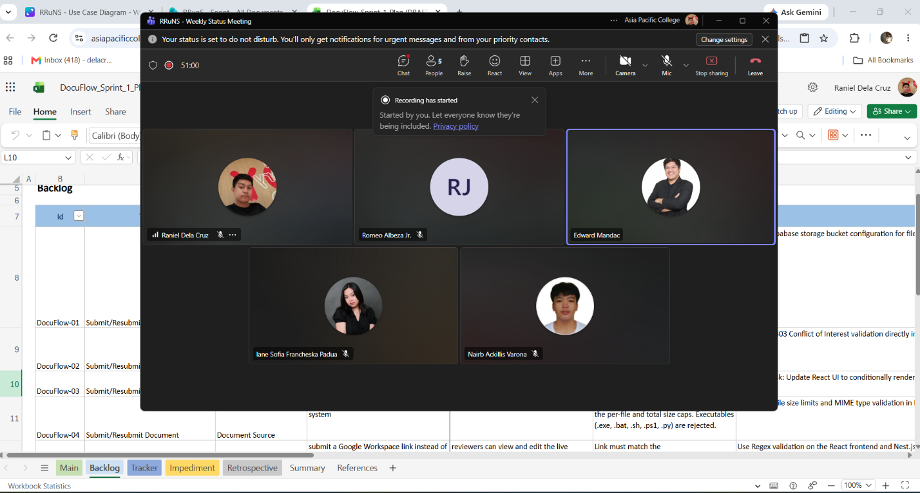
Weekly Status Report: Minutes of Meeting
- Date: Monday, September 14, 2026
- Meeting Called By: RRuNS Team
- Facilitator: Edward Mandac
- Link of the Meeting: Recap: RRuNS - Weekly Status Meeting Monday, 14 September | Meeting | Microsoft Teams
- 1. Attendees
- Nairb Ackillis Varona
- Romeo Jr. Albeza
- Iane Sofia Francheska Padua
- Raniel Q. Dela Cruz
2. Agenda
- Discussion of sprint
3. Summary
- Status update for the week:
  - The team reviewed the progress and goals for the current sprint cycle, aligning development tasks with upcoming project milestones.
  - Discussed task distribution, ongoing feature implementation, and timeline targets for the sprint deliverables.
- Blockers/Obstacle that encountered this week:
  - Managing sprint velocity and ensuring all assigned tasks for the cycle are completed efficiently within the timeline.

